Metrics

Garrett Huxtable

January 18, 2016

GAT 399 Spring 2016

Boyan Radakovich

Preface:

For my paper, I will be focusing on a problem within the scope of game development and testing within schools and how to solve the issue on a student budget as opposed to the industry as a whole. At the school and independent levels of game design, testing is often one of the least emphasized processes. Many of the tests which are run on DigiPen campus utilize the same small subset of the school’s population who have the time and willingness to participate, focus on self-reporting (often verbally), and only occasionally utilizes critical observation. While a much larger text could be written on the many ways in which we could improve testing at DigiPen, I will be focusing on physiological tools we can utilize to improve our testing methodologies.

The Problem:

Outside of triple-a companies, I have heard little in the way of utilizing physiological cues in the process of game development and testing. My first introduction to physiological testing came when Valve visited campus for a talk last semester and spoke about how they built their own GSR device. With a few simple components, they were able to measure a player’s response to their games on a level that went far beyond what self-reporting can do. Not only had this not even been presented as a possibility at the school prior, there had been very little in the way of education about proper testing methodologies or how to retrieve the best data.

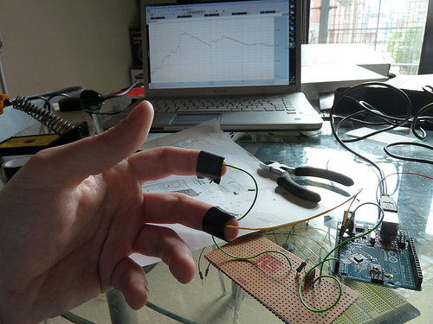

Proposed Metric and Definition:

Metric – Player Arousal

Definition – The level of engagement a player feels in terms of their excitement and stress while playing or experiencing a game as measured by a galvanic skin response sensor.

Example of a crude, low budget, GSR device

http://www.physiologicalcomputing.net/?p=2460

Testing Methodology:

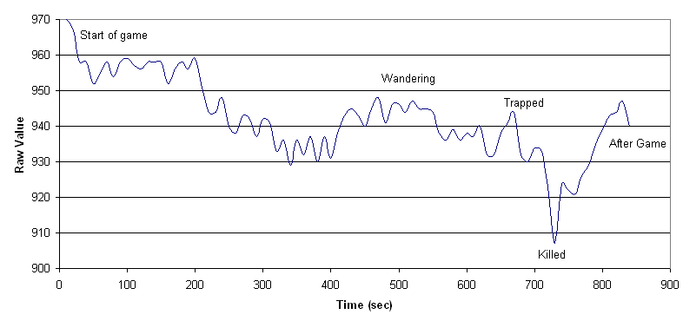 Play testers will be connected to a GSR device either by their fingers or embedded into a controller as they play a game. The GSR device is attached to the computer running the game and code within the game itself will begin recording of GSR data as gameplay proceeds. Gameplay will be recorded alongside the GSR data utilizing screen capture software such as FRAPS. Simultaneously, an observer will record their findings via critical observation and a camera attached to the computer will record the face of the tester. When the game testing is complete. The game will store the recorded GSR data and export it into a graph which can be shown alongside the gameplay and player facial recording so that an analyst can scrutinize the information and form a conclusion.

Data from a LEGO Mindstorms GSR

http://www.extremenxt.com/blog/?page_id=323

Hypothesis:

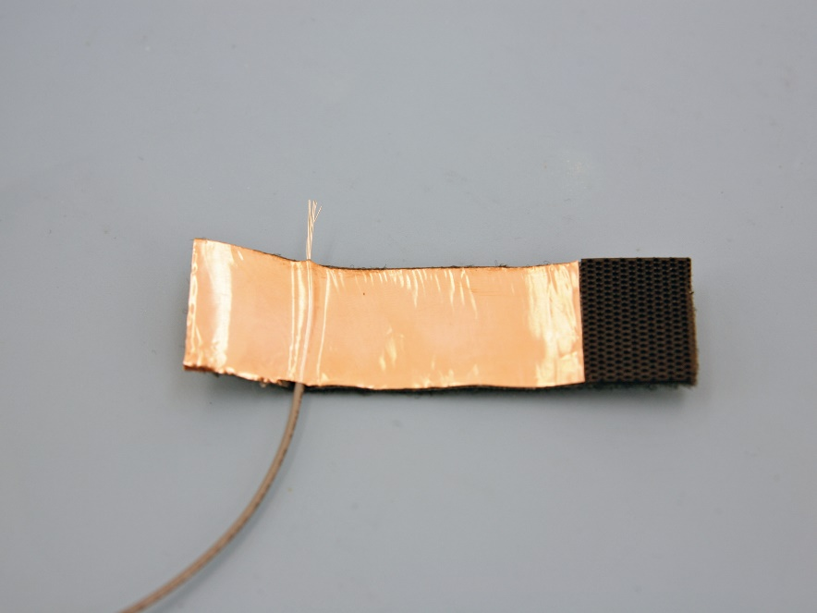 This can be done on a student budget by utilizing the cheap microprocessors available today via companies such as Arduino. Utilizing an Arduino, a breadboard, some wiring, a USB connection, and some copper foil, a student can build a crude but effective GSR device for under $60. After the Valve talk last semester, I ordered the components necessary to build my own GSR device over winter break. The parts arrived late and I have not yet had time to construct the device. Once I do have the device built, it will become a regular part of my testing procedure while at DigiPen and beyond. I will start by building the device as outlined in several articles I have found, using thin strips of copper foil to wrap around the fingers to gather the GSR data. I will also be testing out whether or not attaching the copper foil to a controller produces the same or similar results, as it may be less intrusive and therefore have a lesser impact on testing.

Copper foil for GSR device

http://makezine.com/projects/the-truth-meter-2/

By utilizing galvanic skin response, I will be able to properly measure player arousal while they are engaged with my games. This will aid me in knowing what players respond well to, as well as where there may be faults in the design. Coupled with critical observation as a modicum of self-reporting via Likert scales, I can elevate my game design by knowing exactly how players are unconsciously responding to my games. This will aid me because unlike self-reporting and critical observation, biases on both the tester and observer end are completely avoided. The major risk is a misunderstanding of the data by an untrained analyst. Though I can collect the data and analyze it, having no experience analyzing such data may prove a hindrance as I begin. Overtime this will dissipate and eventually become a nonfactor.

If I have time this semester, I may build my device and then utilize the results of my tests as a response to this hypothesis, to further my capabilities and understanding.